Ryan Woodward
100201137
CPSC 1050 – 003
Feb 3, 2015

CPSC 1050: Introduction to Computer Science

Lab #7: Computer Cycling
Lab Manual (Lab #5)

Useful Links
- Lab manual applets: : http://faculty.mc3.edu/pvetere/Applets/

Exercise 1(12)
- [3 marks] Use: Example 1 – sequence. The program is three instructions long, in memory addresses 0, 1, and 2. Write down (type ) the three instructions or take a screenshot.
Address 0: 0100 0000 0000 0101
Address 1: 0001 0000 0000 0100
Address 2: 0101 0000 0000 0101
Address 3: 1111 0000 0000 0000
- [6 marks] Decode the three instructions. Look at the first four bits of each memory cell and find those bit patterns in the opcodes key. Write down the corresponding three-letter mnemonic.

Address 0: LDI 5 – Load the value 5 directly into the accumulator
Address 1: ADD 4 – Fetch the number located in memory 4 and add it to the accumulator.
- This will add 40 to the accumulator
Address 2: STO 5 – Store the accumulator’s value (now 45) into memory location 5
Address 3: STP – Stops the computer
3. [3 marks] How many fetch-execute cycles will this program perform when you run it?
This program will run four fetch execute cycles. One each for instruction located in memory addresses 0, 1, 2, 3, and 4

Exercise 2(5)
- [5 marks] Use: Example 2 – input and output.
- Modify the program. In place of the STP instruction in word 2, encode a STO (store) instruction that will store the accumulator value in memory cell 10.
- Since you replaced the STP instruction, you should create a new STP instruction in word 3, to make sure your program halts/stops.
- Run your program. When it finishes, you should see your input number in the memory cell labeled 10.
- Take a screenshot of your program.

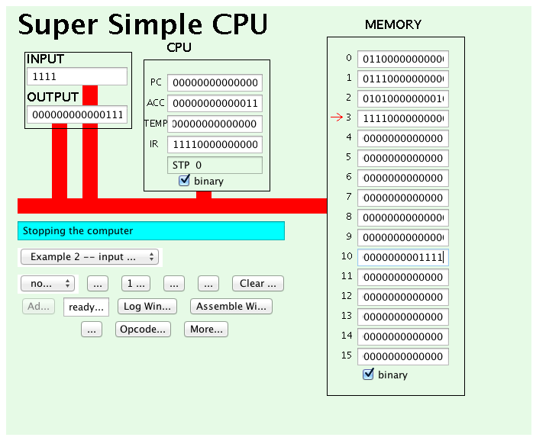

Exercise 3(15)
- [2 marks] Type the following instruction into memory cells 0 and 1. (16th bit)
Do not include the spaces
0100 0000 0000 1110
0011 0000 0000 1110
- In cell 14, type the following:
0000 0000 0001 0101

- Run the program by single-stepping. Press the “1 step” button. After the first instruction finishes (the blue box will say “Updating PC”), write down its three-letter mnemonic and the value in the accumulator.

LDI 14
Accumulator Value: 0000000000001110

- [2 marks] Press “1 step” again to run the second instruction and write down the mnemonic and the accumulator’s value.

LOD 14
Accumulator Value: 0000000000010101

- [1 mark] Take a screenshot
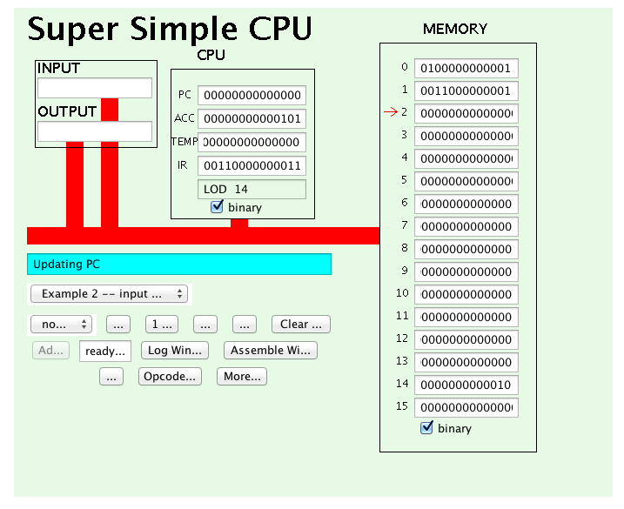
- [4 marks] Explain the difference between the two instructions. (Hint: They are both loading instructions which means they cause a new number to be put into the accumulator. But there is a difference.)

- The first instruction LDI 14 will load the immediate value (14) into the accumulator, whereas the instruction LOD 14 will look to the memory address 14 and then load that value into the accumulator
- [2 marks] Why do you suppose there is no “store immediate” instruction?

- There is already a STO instruction that tells the computer which memory address to store the value in the accumulator. If there where a store immediate instruction, where would it store the number that you give it? Therefore this instruction would be redundant.

- [4 marks] What sequence of regular instructions could be used to do the same thing? That is, how could we store a specific number, say 129, into a specific memory location, say memory cell 12?
LDI 129 – 0100000010000001 (Load 129 into accumulator)
STO 12 – 0101000000001100 (Store value in accumulator to memory location 12)

Exercise 4(12)
- Load the counting loop example (Example 5)
- [5 marks] Run the applet and write down the PC after each instruction

Program Counter initially set to 0
Instruction 0: PC = 0000 0000 0000 0001
Instruction 1: PC = 0000 0000 0000 0010
Instruction 2: PC = 0000 0000 0000 0011
Instruction 3: PC = 0000 0000 0000 0001 (At this point it JMP 1: jumped to instruction 1)
Instruction 1: PC = 0000 0000 0000 0010
Instruction 2: PC = 0000 0000 0000 0011
Instruction 3: PC = 0000 0000 0000 0001 (At this point it JMP 1: jumped to instruction 1)
Instruction 1: PC = 0000 0000 0000 0010
Instruction 2: PC = 0000 0000 0000 0011
Instruction 3: PC = 0000 0000 0000 0001 (At this point it JMP 1: jumped to instruction 1)
Instruction 1: PC = 0000 0000 0000 0010
Instruction 2: PC = 0000 0000 0000 0011
Instruction 3: PC = 0000 0000 0000 0001 (At this point it JMP 1: jumped to instruction 1)
Instruction 1: PC = 0000 0000 0000 0010
Instruction 2: PC = 0000 0000 0000 0011
Instruction 3: PC = 0000 0000 0000 0001 (At this point it JMP 1: jumped to instruction 1)
Instruction 1: PC = 0000 0000 0000 0010
Instruction 2: PC = 0000 0000 0000 0011
Instruction 3: PC = 0000 0000 0000 0001 (At this point it JMP 1: jumped to instruction 1)
Instruction 1: PC = 0000 0000 0000 0010
Instruction 2: PC = 0000 0000 0000 0011
Instruction 3: PC = 0000 0000 0000 0001 (At this point it JMP 1: jumped to instruction 1)
Instruction 1: PC = 0000 0000 0000 0100 (At this point JNG 4 activated at it jumped to ins. 4)

- [2 marks] Take a screenshot and circle all the jumping instructions.

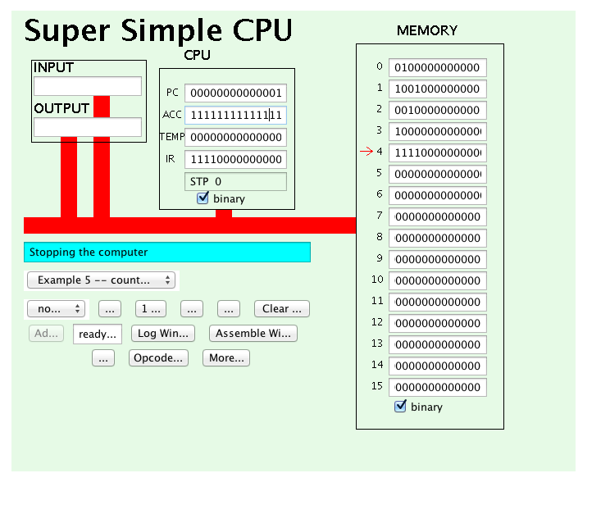
The jumping instructions are located in Memory Addresses 1 and 3

- [5 marks] Be a human “disassembler.” Translate the computer instructions in cells 1 to 5 into mnemonics. Remember, only the first 4 bits of each instruction is the opcode. To see the opcode list, click on the “Opcode list” button.
LDI 6 – 0100 0000 0000 0110
JNG 4 – 1001 0000 0000 0100
SUB 5 – 0010 0000 0000 0101
JMP 1 – 1000 0000 0000 0001

Exercise 5 (6 bonus)
  - [2 marks] Click the Reset button. Click on the binary checkbox at the bottom of memory so that decimal numbers appear in memory instead of binary. In location 14, type 16 and in location 15 type 28. What do you think the GCD of these numbers will be?

The greatest common divisor of 16 and 28 is: 4

  - . [2 marks] Run the program. When it is done, take a screenshot. Find the memory cell that has the GCD and circle it.
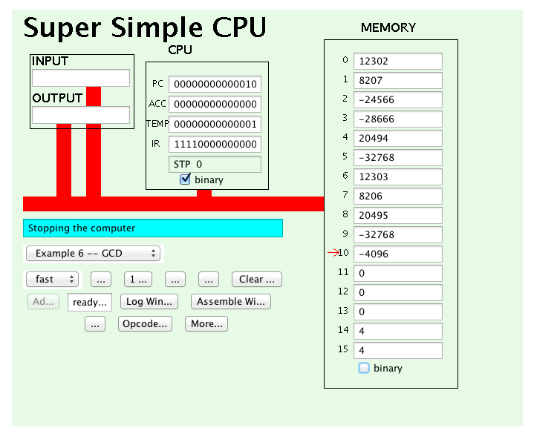
The GCD is located in both memory cells 14 and 15

  - [2 marks] What is the GCD of 20 and 21? You could use the applet to confirm your suspicions. Click on these buttons: Stop, Reset. Then type 20 into cell 14, and type 21 into cell 15. Press the Run button.
- 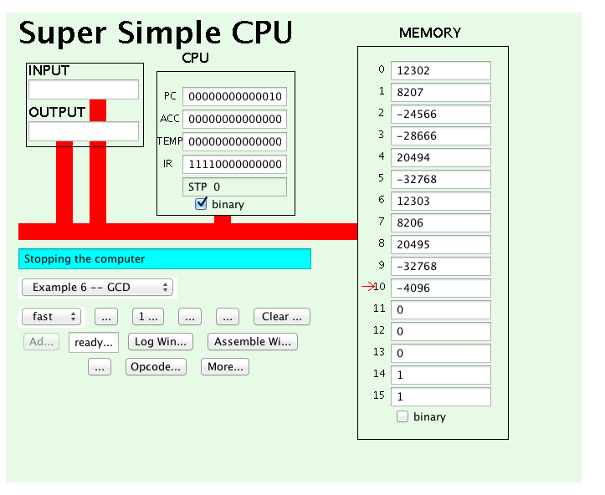
- As evidenced by the applet the GCD of 20 and 21: is 1
[50 marks total]

